**How to create a fiver account? How to create a gig? How to keep an account active? How to take project in fiver?**

**Creating a Fiverr Account:**

* Go to the official Fiverr website at [www.fiverr.com](http://www.fiverr.com).

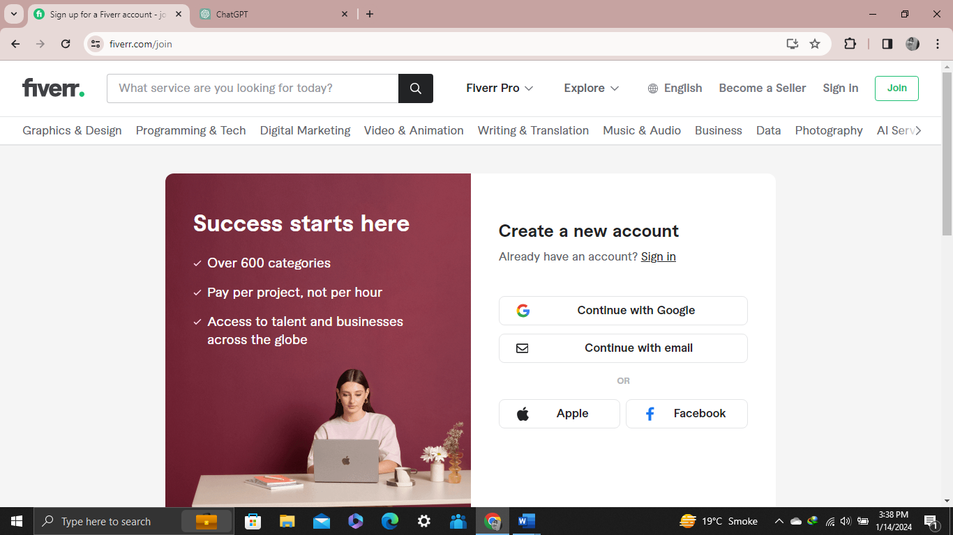

* Click on the "Join" or "Sign Up" button. You can sign up using your email, Google account, or Facebook account.

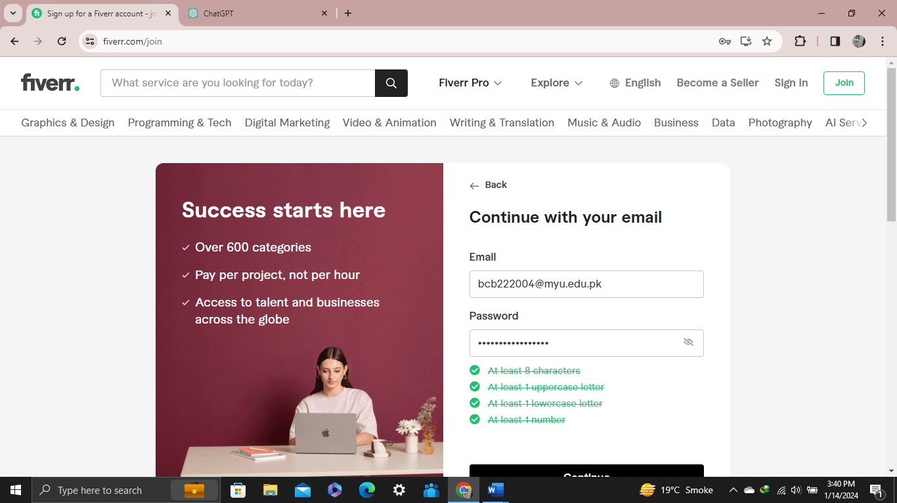

* Fill in your details, including your name, email address, and password. You will also need to set up your profile by adding a profile picture, writing a bio, and specifying your skills.
* Fiverr will likely send a verification email. Click on the link provided in the email to verify your account.

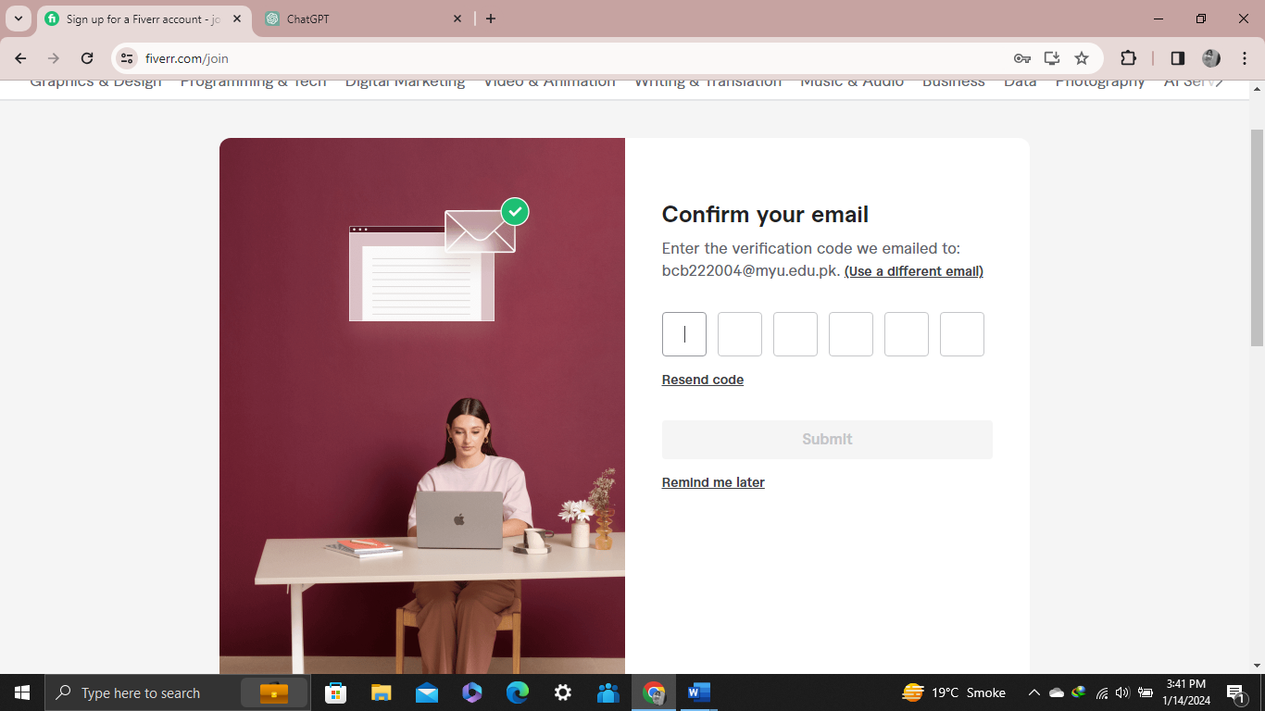

* Account created.

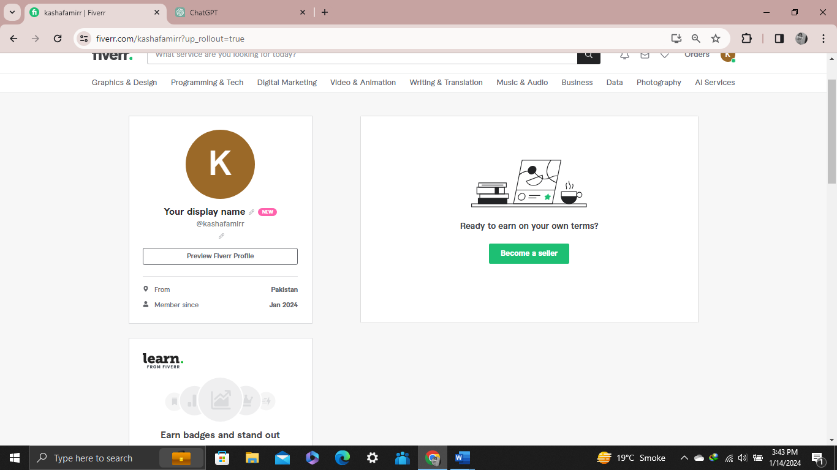

**Creating a Gig:**

* Once logged in, go to your dashboard. There, you'll find options to create a new gig.
* Click on "Create a New Gig" or a similar option.
* Choose a category and subcategory for your gig.

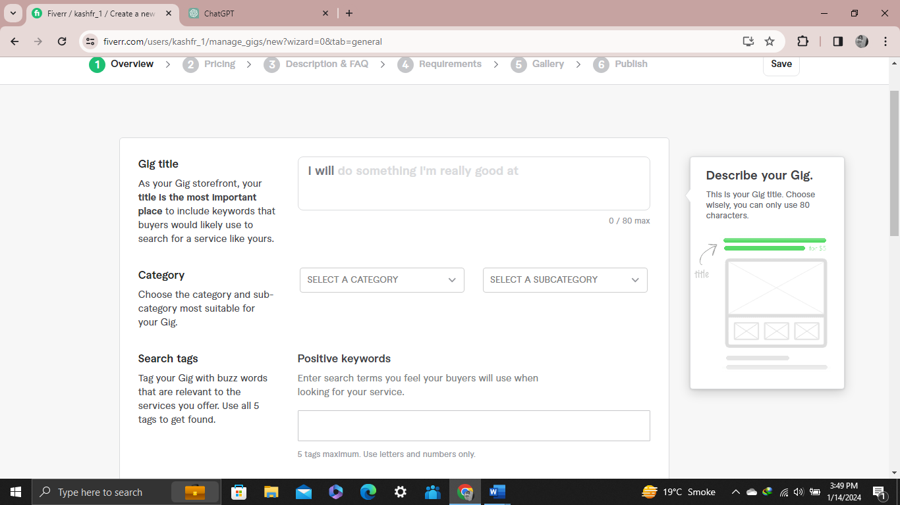

* Fill in the details of your gig, including the title, description, pricing, delivery time, and any additional options you want to offer.

* You can add extras to your gig to provide additional services for extra fees.

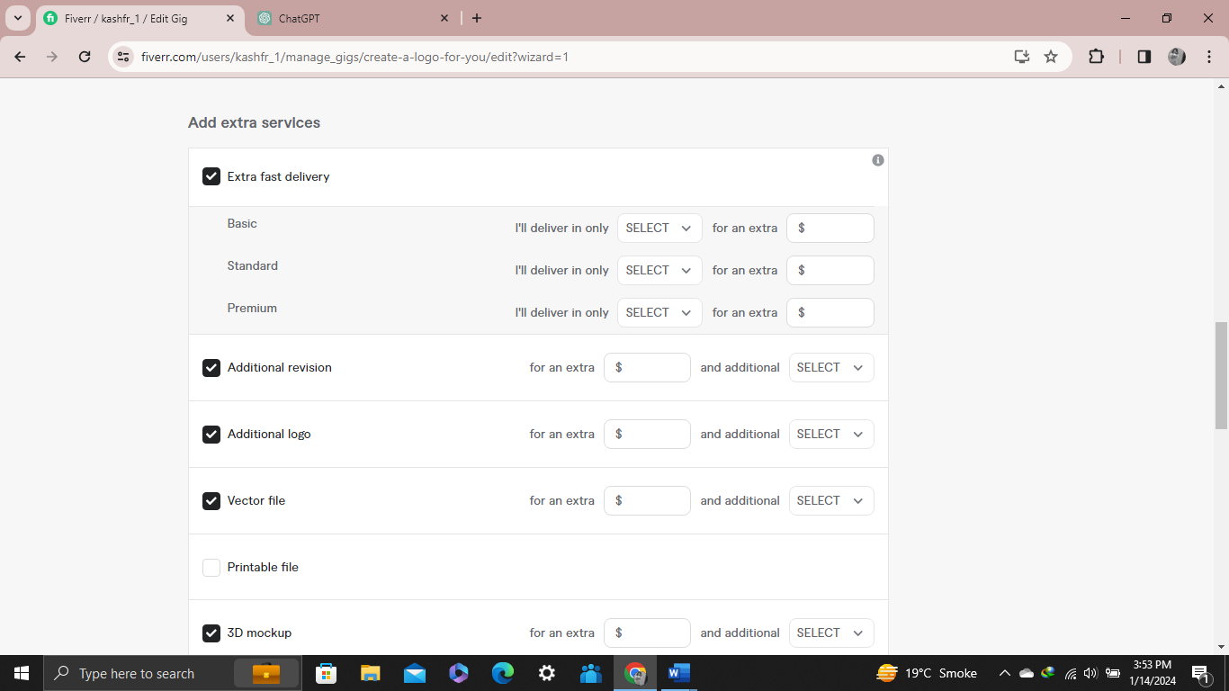

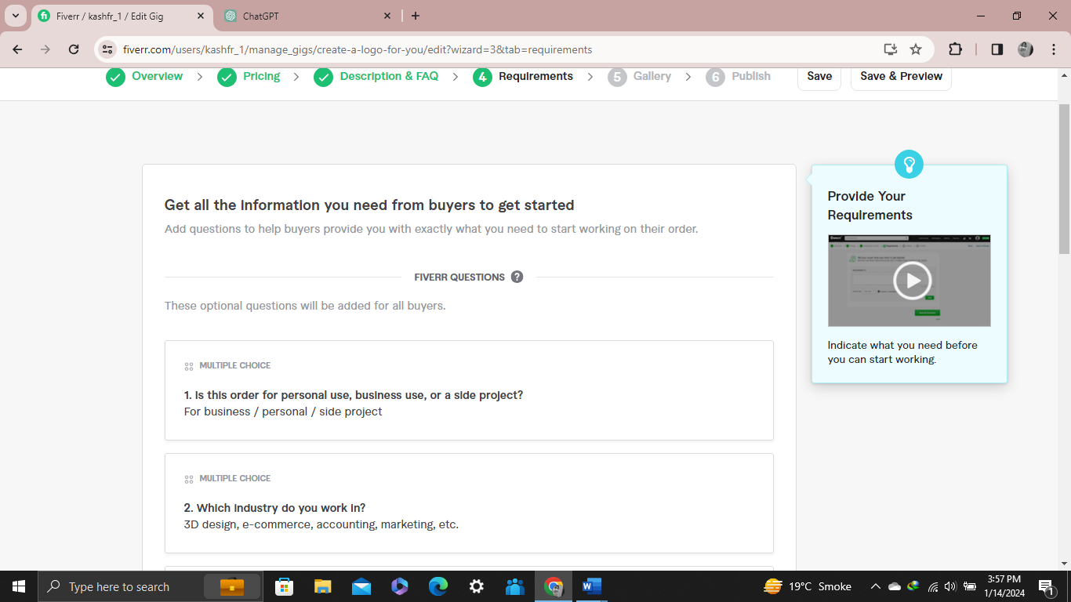

* Add high-quality images and, if possible, videos that showcase your work or describe your services.
* Choose relevant tags to help your gig appear in search results.
* Once you've filled in all the necessary details, click on the "Publish Gig" button.

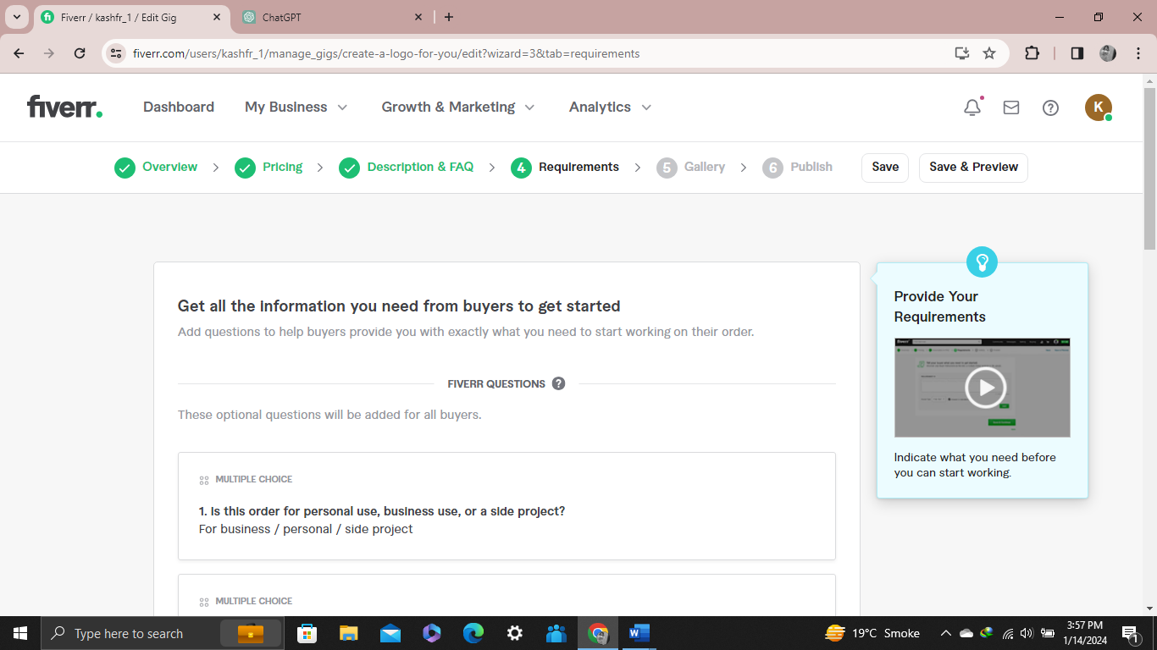

**Keeping Your Account Active:**

* Keep your profile information, skills, and portfolio updated to reflect your current expertise.
* Respond quickly to messages from potential clients to show that you are active and engaged.
* Consistently provide high-quality services to receive positive reviews. Positive reviews can significantly improve your chances of getting more projects.

**Taking Projects on Fiverr:**

* Check the "Buyer Requests" section regularly for new project opportunities.
* Share your gig on social media platforms and promote it to increase visibility.
* Use relevant keywords in your gig description and tags to improve its search engine optimization (SEO) and visibility.
* Price your services competitively, especially when you're starting, to attract potential clients.
* Continuously update and enhance your portfolio to showcase your skills and attract more clients.